**QwikLab: Intro to Amazon API Gateway**

Time Spent: 50 min

**Overview**

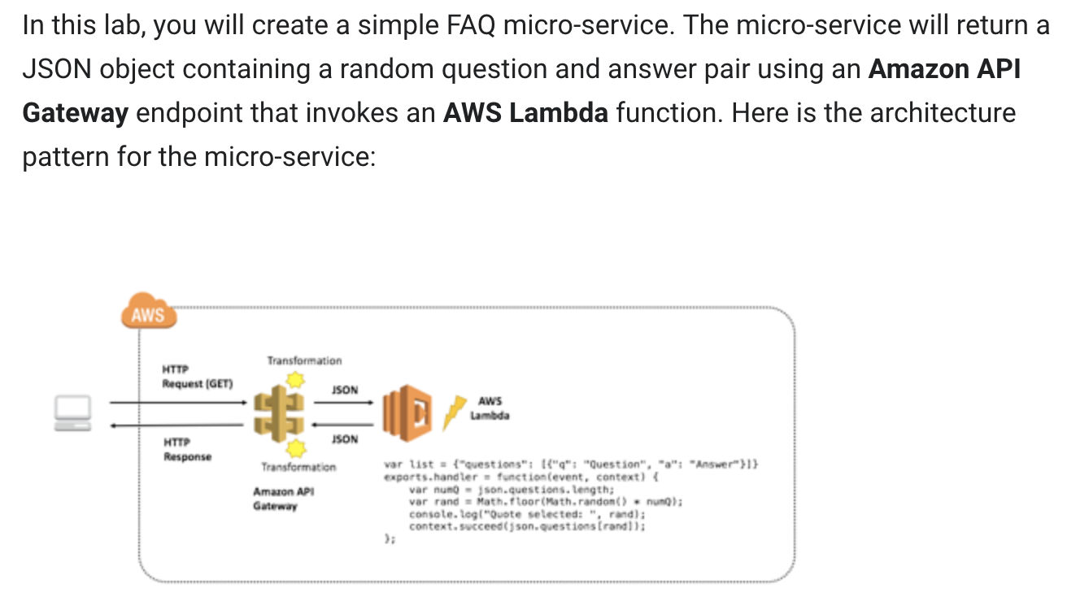

**What I learned:**

* How to create AWS lambda function
* How to create Amazon API Gateway endpoints
* Useful concept of Web development: API, RESTful etc.
* Although the lab isn’t complicated, but the most important thing is under stand the mechanism of API Gateway and Lambda fuction
* We used both http call(on browser endpoints) and test by empty JSON object

**What I built:**

* **Built the Lambda fuction and use API Gateway to test it**

